Project Design Phase-II
Data Flow Diagram & User Stories

Date | 5 October 2026
Team ID | SWTID-2026-4912
Project Name | AI StudyBuddy
Maximum Marks | 4 Marks

Data Flow Diagrams:
The DFDs show how data enters and leaves AI StudyBuddy, which processes handle it, and where it is stored.
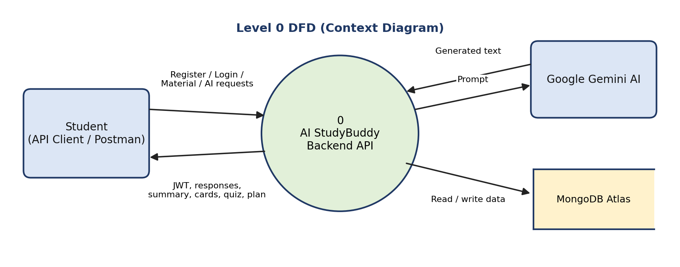
Figure 1: Level 0 DFD
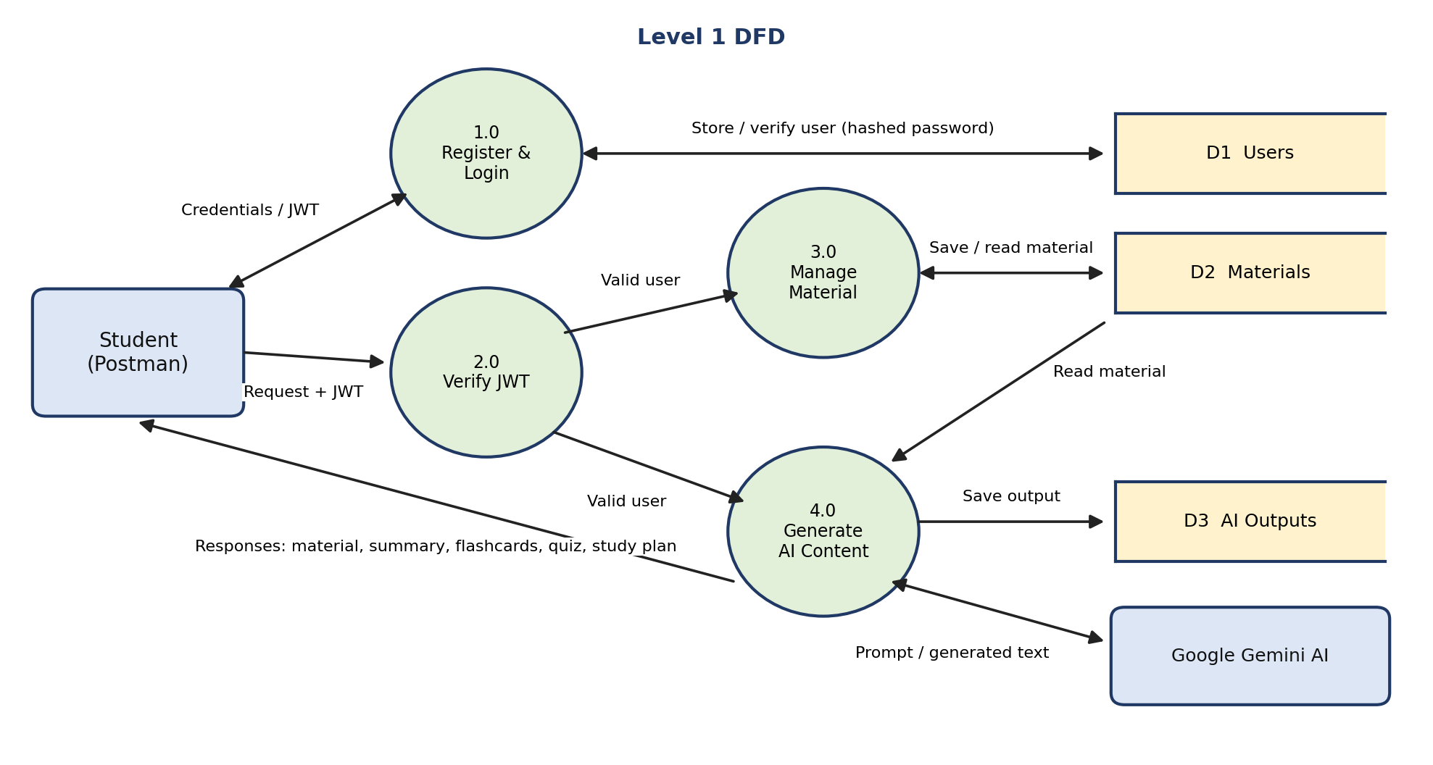
Figure 2: Level 1 DFD
User Stories
User Type | Functional Requirement (Epic) | User Story Number | User Story / Task | Acceptance criteria | Priority | Release
Student | Registration | USN-1 | As a student, I can register by entering my name, email, and password. | Account is created and a token is returned | High | Sprint-1
Student | Registration | USN-2 | As a student, I want my password stored securely. | Password is saved as a bcryptjs hash | High | Sprint-1
Student | Login | USN-3 | As a student, I can log in with my email and password. | I receive a JWT token | High | Sprint-1
Student | Secure Access | USN-4 | As a student, I want protected APIs to need a valid token. | Requests with a valid token are accepted | High | Sprint-1
Student | Server Health | USN-5 | As a student, I can check that the server is running. | GET / returns a success response | Medium | Sprint-1
Student | Study Material | USN-6 | As a student, I can upload study material with title, subject, and content. | Material is saved to my account (201 Created) | High | Sprint-2
Student | AI Summary | USN-7 | As a student, I can generate a summary of my material. | A concise summary is returned | High | Sprint-2
Student | AI Flashcards | USN-8 | As a student, I can generate flashcards from my material. | Question-and-answer cards are returned | High | Sprint-2
Student | AI Quiz | USN-9 | As a student, I can generate a multiple-choice quiz. | Quiz questions are returned | Medium | Sprint-3
Student | AI Study Plan | USN-10 | As a student, I can enter a goal, days, and hours per day to get a study plan. | A day-wise plan is returned | Medium | Sprint-3

